EXPERIMENT 3
Survey Report on Emerging Trends in Low-Code Application Development
Application Selected: Job Application Form — Basic Fields Use Case
Platform: Zoho Creator
1. AIM
To study the emerging trends in low-code application development and understand how Zoho Creator can be used to develop a Job Application Form with minimal coding using basic form fields, validation, and workflow features.
2. Traditional Application Development vs Emerging Low-Code Application Development
Traditional Development | Low-Code Development
Requires extensive programming | Requires minimal coding
Development takes more time | Faster application development
Requires skilled programmers | Can also be developed by non-experts
UI and database are usually coded manually | Visual drag-and-drop interface
Testing and deployment require more effort | Faster testing and deployment
High customization | Customization depends on platform
More control over application architecture | Platform manages much of the infrastructure

Emerging trends: visual development, workflow automation, reusable components, cloud-based development, rapid prototyping, API integration and AI-assisted application development.
3. Benefits and Challenges of Low-Code
Benefits
- Faster development
- Less coding effort
- Easy form creation
- Rapid prototyping
- Easy workflow automation
- Reduced development cost
- Easier maintenance
Challenges
- Limited customization in some cases
- Platform/vendor dependency
- Security concerns
- Integration limitations
- Performance limitations for complex applications
- Licensing costs
4. Comparison of Existing Platforms
Platform | Main Use | Key Feature
Zoho Creator | Business applications | Visual application builder
Microsoft Power Apps | Business applications | Microsoft ecosystem integration
Mendix | Enterprise applications | Rapid low-code development
OutSystems | Web/mobile applications | Full-stack low-code development
Appian | Business processes | Workflow automation

Platform selected for this experiment: Zoho Creator is used to develop the Job Application Form with basic fields, validation rules, report generation and workflow features.

OUTPUT
The screenshots provide output evidence of the developed Job Application application in Zoho Creator.
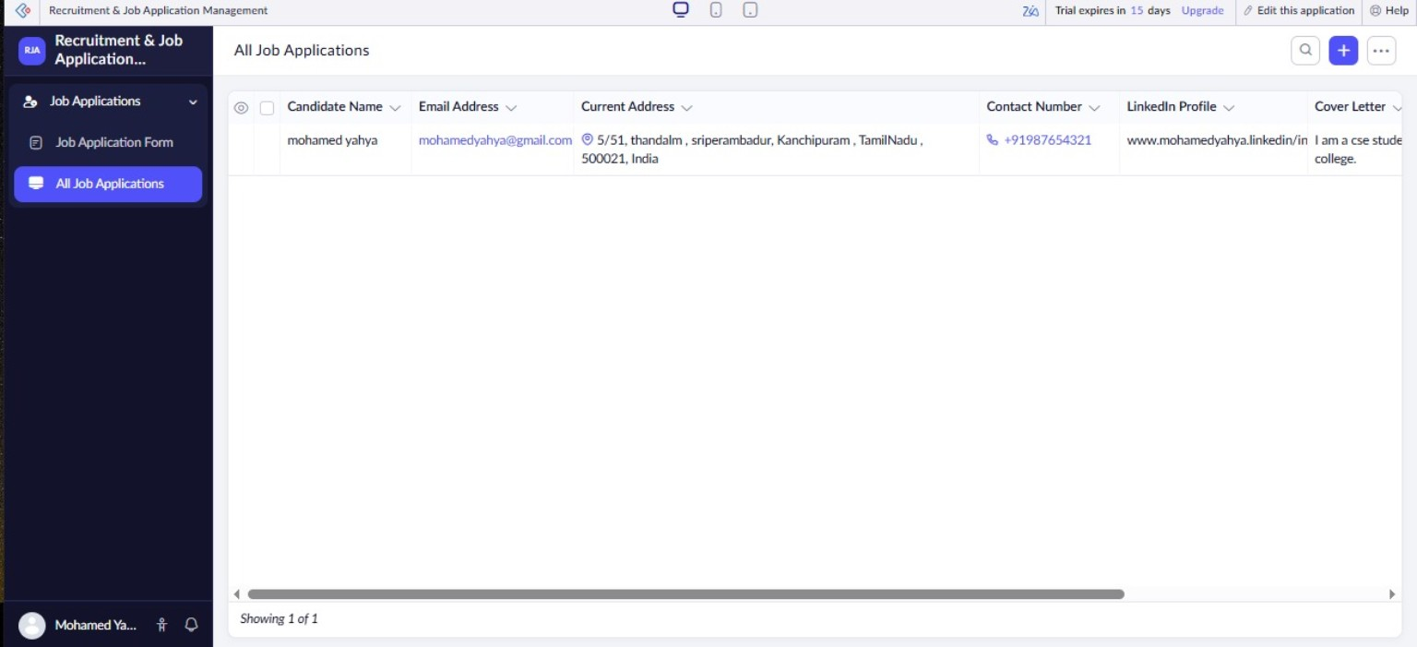
Figure 2: Candidate Application Report — output view.
Figure 1: Candidate Application Report showing the submitted job application.

5. RESULT
The study of low-code application development was successfully completed. The Job Application Form can be developed using Zoho Creator with basic fields, validation rules, reports and workflows with minimal programming effort. The experiment demonstrated how low-code platforms can simplify and accelerate application development.
Practical Work / Evidence to be Added
- Screenshot of the Zoho Creator Form Builder showing all 13 fields.
- Screenshot of the live/preview Job Application Form.
- Screenshot of Candidate_Application_Report showing at least 3 submitted records.
- GitHub repository link containing the report and practical-work evidence.

